**Experiment No. 9**

**Title:** Categorizing Amazon Web Services (AWS) and Implementing Cloud Entities Using Cloud Toolbox Support

**Objective:**

To categorize and implement various cloud entities offered by Amazon Web Services (AWS) using its Cloud Toolbox support, understanding the diverse services available for cloud computing.

Tools used:

- Amazon Web Services (AWS) Console

- Cloud Toolbox

**Prerequisite:**

- An AWS account with necessary permissions and access

- Basic understanding of cloud computing concepts

**Theory:**

Amazon Web Services (AWS) is a comprehensive cloud computing platform offering a wide range of

[](https://www.google.com/url?sa=i&url=https://logos-world.net/amazon-web-services-logo/&psig=AOvVaw13uGdsJZBahmL9He0VDrJp&ust=1701269045003000&source=images&cd=vfe&ved=0CBIQjRxqFwoTCIirnZ335oIDFQAAAAAdAAAAABAR" \t "/Users/pratham/Documents/Pratham/Final_Year/CC/CC Practice/x/_blank)

services. These services are categorized into various types, including compute, storage, databases, networking, and more, providing flexibility and scalability for diverse computing needs.

**Steps to Categorize and Implement AWS Cloud Entities Using Cloud Toolbox Support:**

**Step 1:** Access AWS Console

1. Visit the AWS Management Console: Open a web browser and go to <https://aws.amazon.com>

2. Login: Enter your credentials (username and password) to access the AWS Management Console.

**Step 2:** Navigate to Cloud Toolbox

1. Explore Services: Once logged in, you'll land on the AWS Management Console dashboard. Look for the navigation menu on the top-left or top-right corner.

2. Locate Cloud Services: Find the section labeled "Services," which houses the Cloud Toolbox or Cloud Services. Click on it to explore the range of AWS services available.

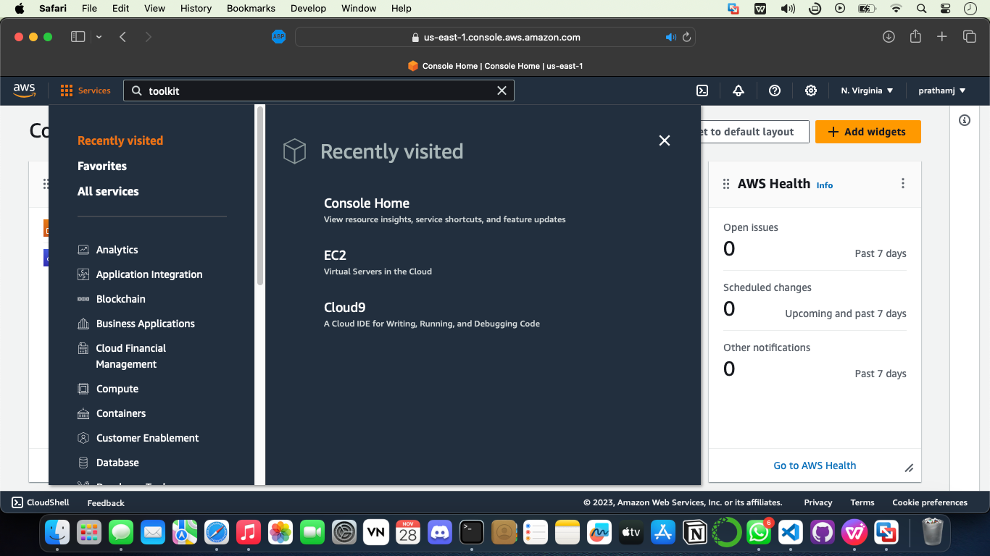

**Step 3:** Categorize AWS Services

1. Understand Functional Categories: AWS services are grouped into categories based on their functions such as compute, storage, databases, networking, etc.

2. Explore Categories: Navigate through each category (e.g., Compute, Storage, Database) to see the services listed within them. Click on each service to learn more about its purpose and functionalities.

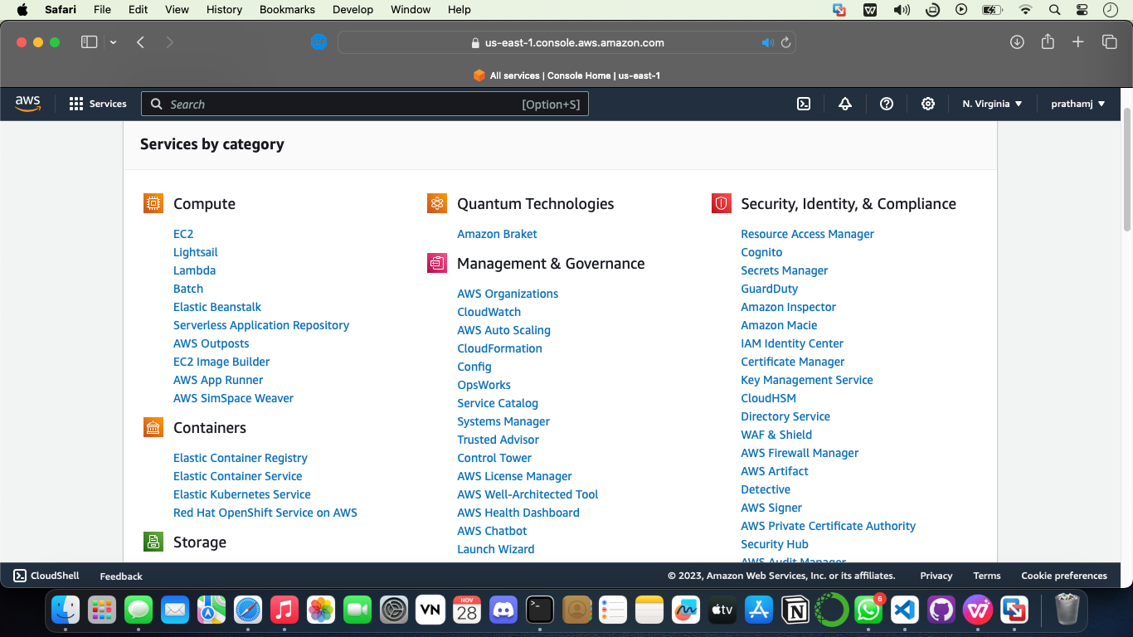

**Step 4:** Implement Cloud Entities

1. Choose Services for Use Case: Select a service (or multiple) based on your intended use case. For example, Amazon EC2 for compute or Amazon S3 for storage.

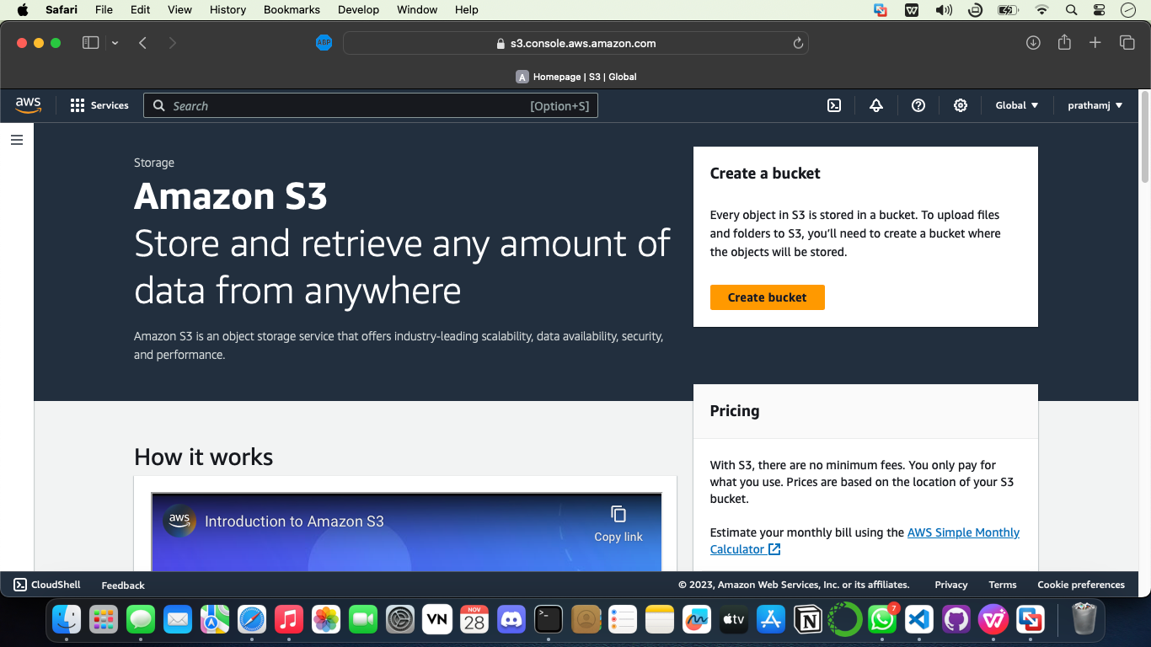

2. Access Service Interface: Click on the chosen service within the AWS Console to access its interface or wizard.

3. Create and Configure: Follow the service's interface or wizard to create and configure the cloud entity. This might involve specifying settings, such as instance type, storage options, security configurations, etc.

**Step 5:** Explore Integration and Management

1. Understand Integration: Learn how different AWS services can work together by exploring their integration capabilities. For instance, how EC2 instances can connect to an RDS database or how S3 can be used with Lambda functions.

2. Management Options: Explore the management features within the AWS Console. Look for tools related to monitoring, scaling, and maintaining the created cloud entities. This includes services like CloudWatch for monitoring and Auto Scaling for scaling resources.

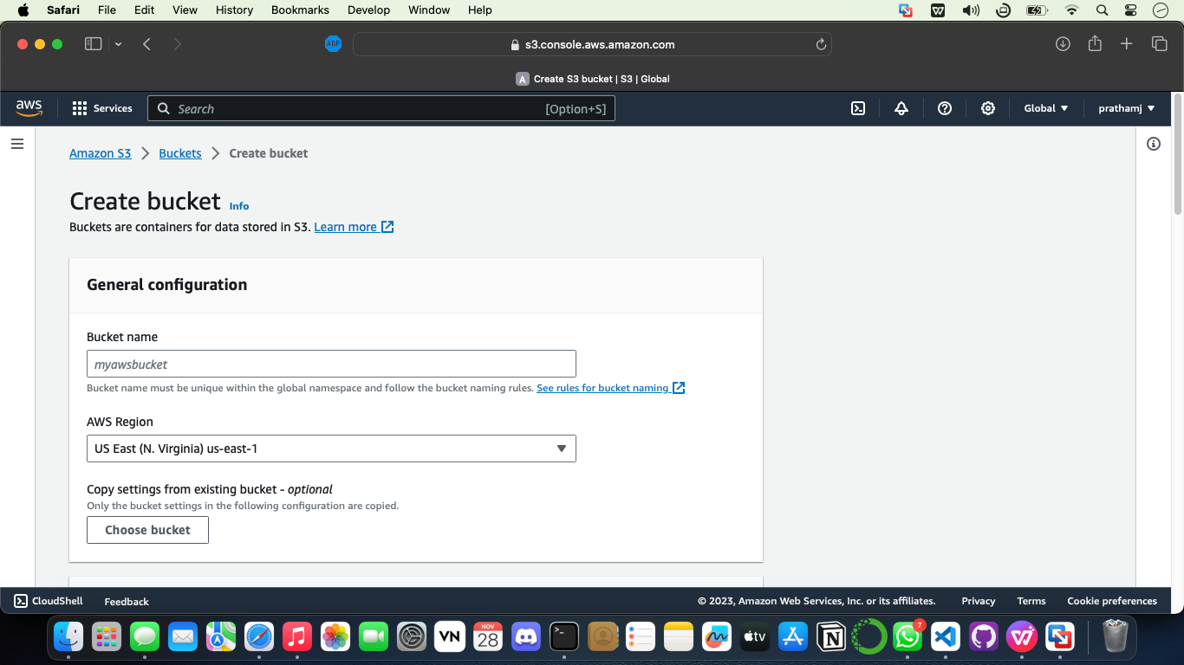

**Step 6:** Experiment with Cloud Services

1. Hands-on Experimentation: Create test instances or resources within the AWS Console to gain hands-on experience with different services.

2. Test Capabilities: Experiment with various functionalities and capabilities offered by the services. For instance, create a test EC2 instance, configure an S3 bucket, set up a simple database using RDS, etc.

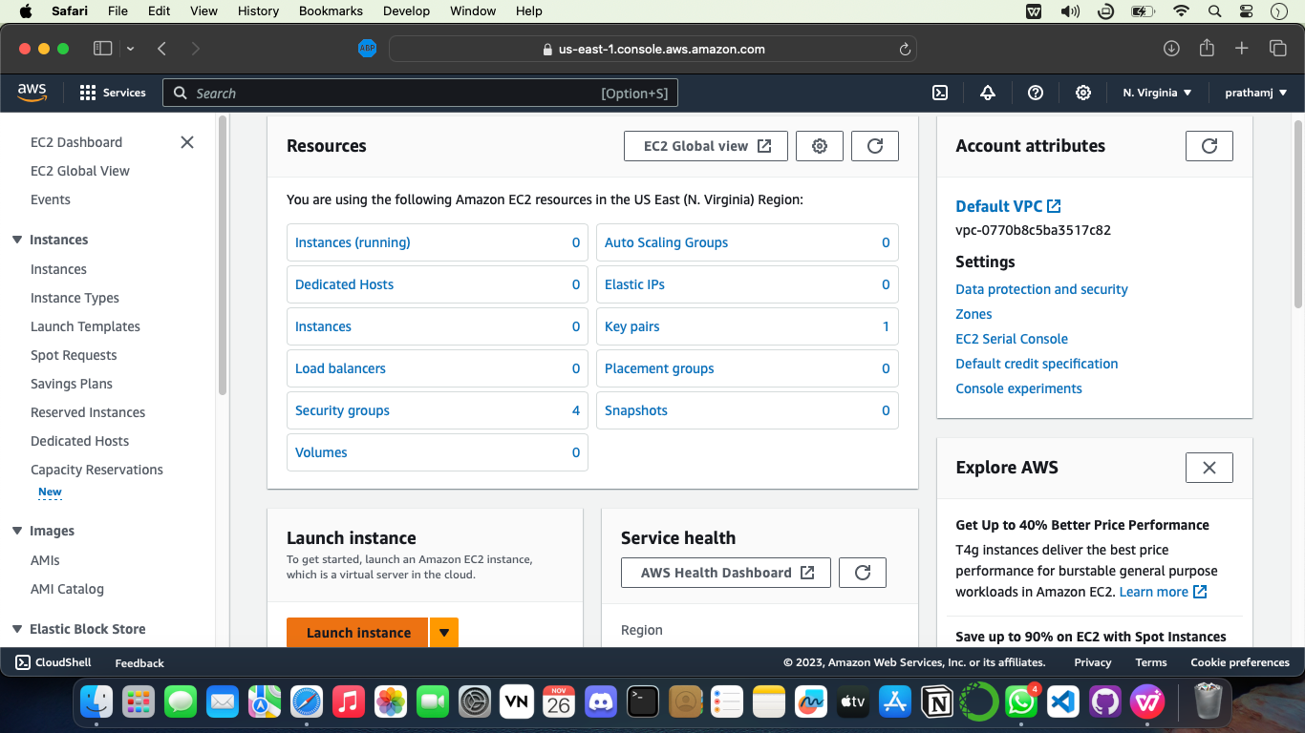

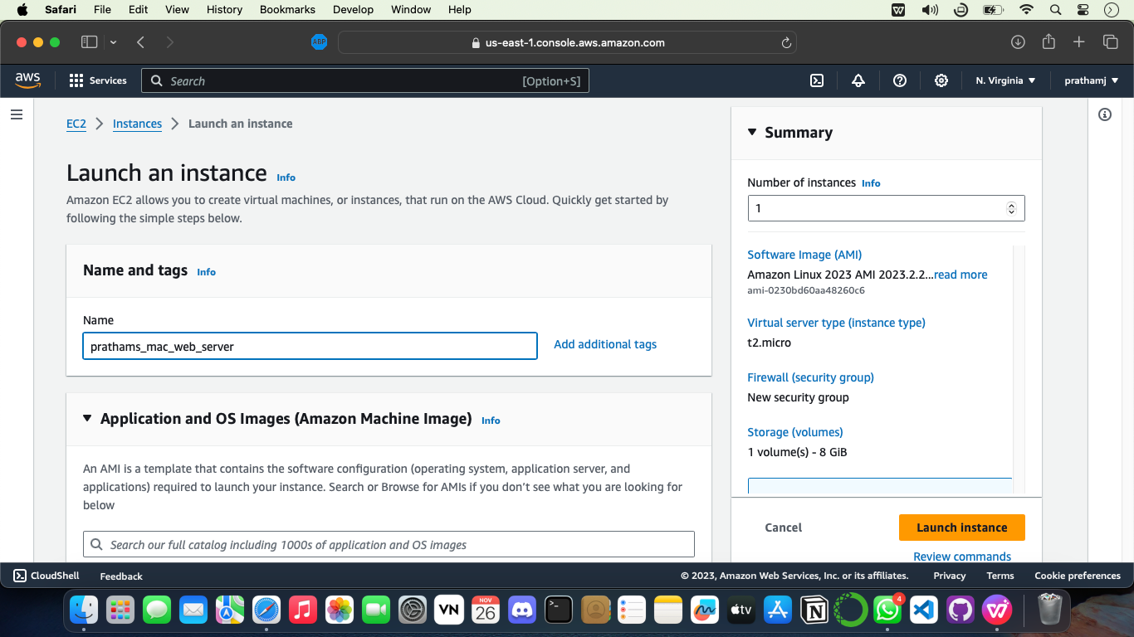

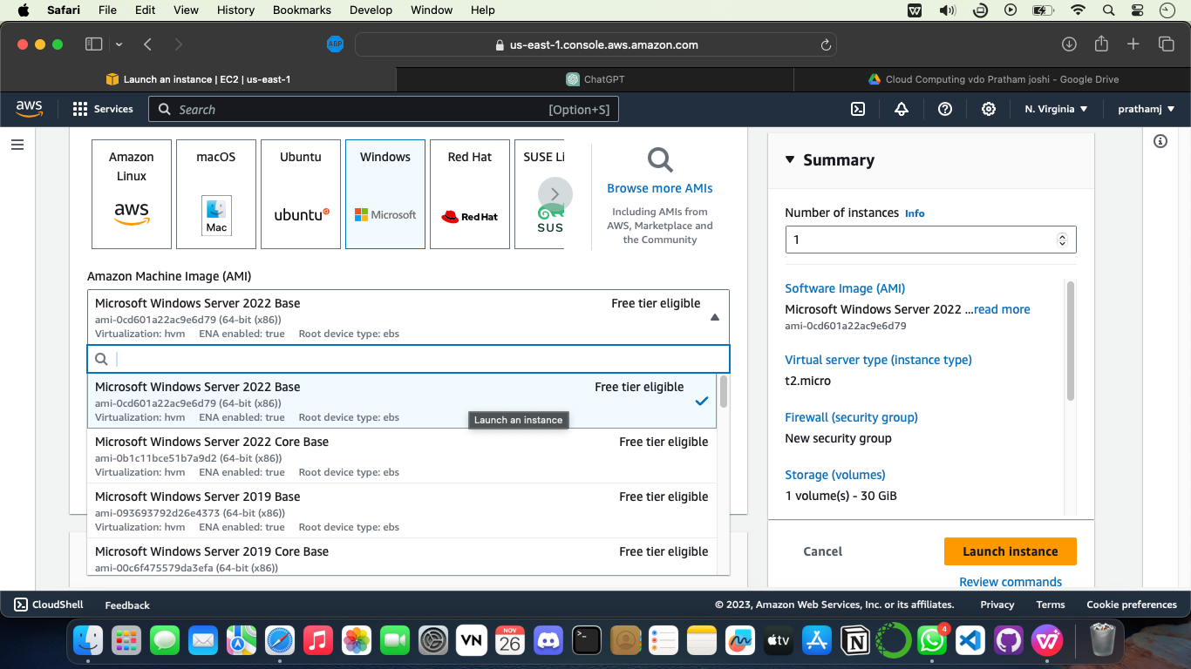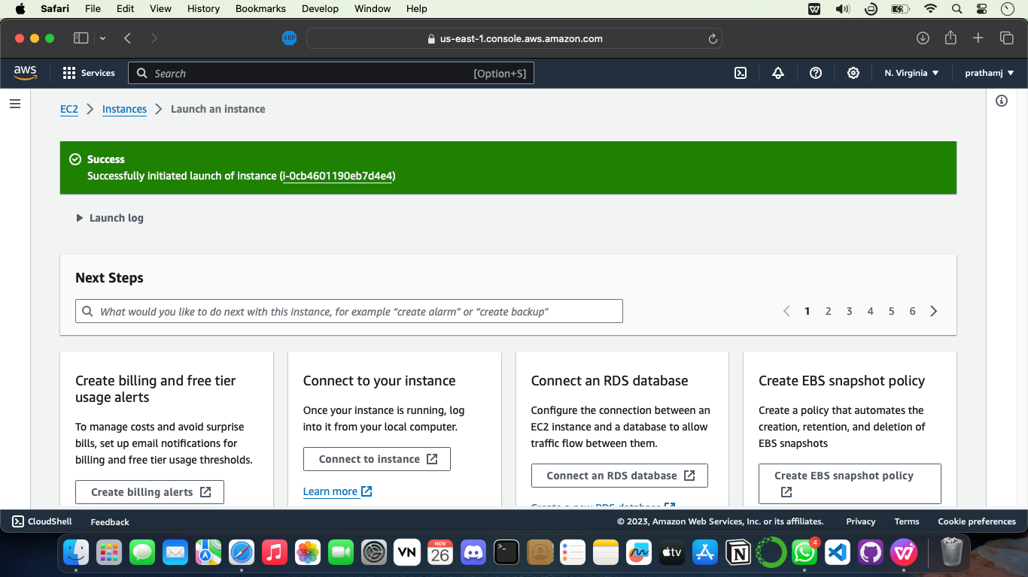

**Conclusion:**

Successfully categorized Amazon Web Services (AWS) into different functional categories and implemented various cloud entities using the Cloud Toolbox support. This experiment demonstrated the diverse range of services offered by AWS, showcasing their functionalities and how they can be utilized to build and manage scalable cloud solutions for different applications and workloads.